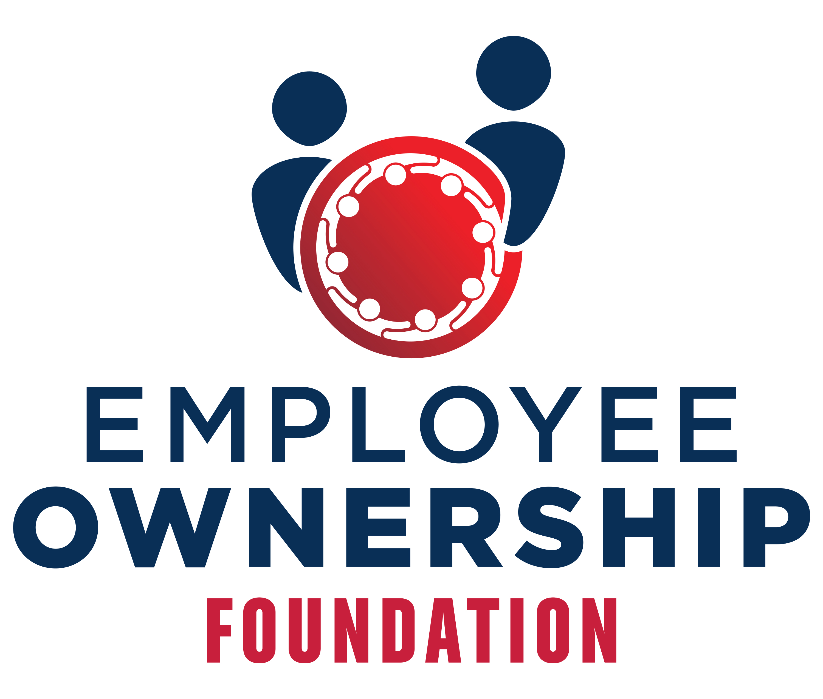
Charles R. Edmunson Scholarship

The Charles R. Edmunson Scholarship offers ESOP companies the opportunity to defray the costs of sending non-managerial employees to an ESOP Association sponsored event. The events include the Employee Ownership Foundation’s Employee Ownership Retreats, the ESOP Association’s National Conference or an ESOP Association Chapter or Regional Chapter Conference.

There are two different scholarship opportunities available that are dependent upon where the company is in their ownership journey, (a) Recognition of Achievement (typically mature ESOPs) and Ownership Thinking Development (new ESOPs or ESOPs rebooting their ownership culture).

If you wish to apply for a scholarship, please note the following important information regarding the application process:

- Applicants are required to be current members of The ESOP Association.
- All applications are due by July 15, 2022.
- Completed applications must be returned to Nicole Reppert at nreppert@esopassociation.org.
- Companies will be notified of receipt of application.
- Award recipients will be selected by September 6.
- Scholarships will not be awarded to the same company two years in a row.
- The scholarship award is $2,000 (awarded to the company and is split equally if the company has two winners).
- Scholarships are nontransferable.
- By applying for the Charles R. Edmunson Scholarship, the employee-owned company agrees to abide by all the terms and conditions of the Charles R. Edmunson Scholarship.

Recognition of Achievement (for mature ESOPs)
Scholarships awarded are to companies for the individuals who play a significant role in the development and enhancement of their company’s successful ownership culture. These companies and the individuals proposed for scholarships are typically mature ESOPs in terms of ownership culture and ownership behavior activities conducted. This category recognizes ESOP champions.

- Recognition of Achievement Application

Ownership Thinking Development (for new ESOPs or companies rebooting their ESOP ownership culture)
Scholarships awarded are to companies for the individuals who are starting the journey to an ESOP culture or who are working to restart/reboot/refresh the ownership culture within the company. These companies and individuals are seeking support to develop skills, knowledge and the practice of ownership culture creation.

- Ownership Thinking Development Application
Disclaimer: The winning applicants’ images and biographies may be used by Employee Ownership Foundation and the ESOP Association on their respective websites as well in news releases and other social media clips. Winning applicants will be provided a release for this purpose after the awards are made.

